**2022 SRLCC Field Data Collection For Evaluating Forest Restoration and Fire Mitigation Management Effectiveness Protocol Addendum:**

**Sampling Objective:**

This protocol is designed by the Colorado Forest Restoration Institute (CFRI) to collect comprehensive data for changes in non-spatial forest structure and composition, fuels and fire potential using the Fuels Characteristic Classification System (within the Fuel and Fire Tools analysis package), and plant species abundance and diversity as a result of management actions in forests and shrublands of Colorado.

In 2010, Colorado Front Range National Forests were awarded a Collaborative Forest Landscape Restoration (CFLR) grant to facilitate the implementation of restoration treatments across 32,000 acres of ponderosa pine-dominated forests and to help inform the adaptive management process in Front Range forests threatened by increasingly severe and frequent disturbances. SRLCC protocols were developed for the first set of sites that were monitored under this collaboration and were used as the basis for CFLRP protocols that were used at later sites.

Monitoring efforts will help answer the following questions:

1. Have restoration treatments increased or maintained total native plant cover and diversity?
2. Have treatments increased or maintained the cover and diversity of native graminoids, forbs, and shrubs?
3. Have treatments increased the cover and diversity of native early successional species?
4. How have treatments increased or maintained the cover of key native plants (to be defined by ARNF/PSINF personnel)?
5. Have treatments minimized increases in total exotic plant cover or diversity?
6. Have treatments minimized increases in the cover of exotic species of concern (e.g., noxious weeds)?

**Differences from standard Mothership protocols are outlined below. Unless a change is highlighted in the addendum, it can be assumed that standard protocols should be followed.**

**Sites Using SRLCC Protocols: HVR (some are a modified version), ESV (Estes Valley), PHA (P1-2, P2-3, Phantom)**

**Main Differences from Other Protocols**

* 1/200th acre seedling and sapling plots, 8.3 ft in radius (not 11.78 ft as in other protocols) *Note: other sizes possible
* 4 transects, not 8. Transect length slightly different (30.75m). 100 intercepts per transect, not 25.
* Saplings recorded in both fixed and variable radius plots

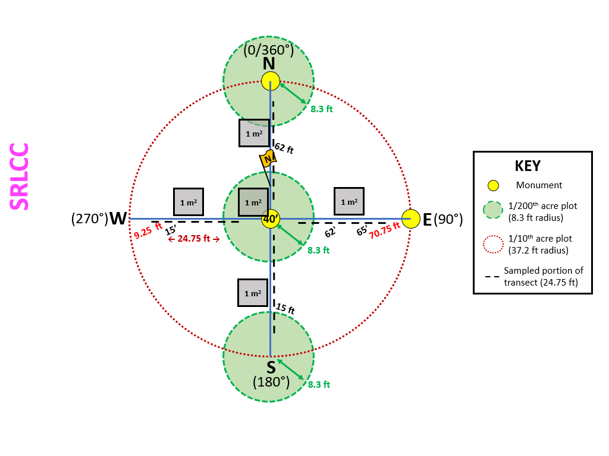

**PLOT LAYOUT:**

1. **Lay out the plot.** From plot center, establish 4 transects in the cardinal (0°, 90°, 180°, 270°) using a **declinated** compass (set – 8.5° east for the Front Range) and two 100 ft tapes extended to 80-ft. Be sure that the 0 ft mark is on the S and W ends of the transect (the reel should be on the N and E ends). Remaining plot set-up and data recording same as Mothership.
2. **Monument.** Install three permanent markers, or monuments, using a nail, yellow painted washer, and a silver “Understory Permanent Research Site” tag. Inscribe plot name, and location (“N,” “Center,” or “E”) on the tag with a pen and write it on the washer with a permanent marker. Monuments should be located at plot center, 37.2-ft north of plot center (North), and 37.2-ft east of plot center (East). Wrap a piece of pink flagging around each washer. Re-flag nails on each revisit or once a year.  Wrap pink flagging around the first live tree that is in the clockwise direction of the North transect. Also, wrap pink flagging around the largest tree in the plot (if northern most tree is also the largest, then flag the second largest tree). Tie the flagging knots facing towards plot origin.

**Variable Radius Plot**

**Tree Overstory**

1. **Prism size:** Record the basal area prism (BAF) size. A 10 BAF Prism should be used for all plots. PIP information may differ. Follow the remaining steps in Mothership protocols.

**1/200th Acre Plot (8.3 ft radius)**

*Check plot lists for radius size as some plots may be different. SRLCC sites have plots at plot center and at the N and S ends of the transect. Unlike Mothership protocols, the N and S plots begin at the very end of the transect. Some years prior to 2022 may only include a center plot measurement.*

**Tree Seedlings and Saplings**

1. **Tree Seedlings:** individuals within the 1/200th acre plot (8.3 ft radius, or other size) that are less than 4.5 ft tall. Add a note if Class A seedlings are recent germinants.  Seedling plot size should be selected as “**fixed radius**” only.

Record the species and number of individuals in each height class.

Class A: < 12 in tall (includes new recruits). Class C: 24.1-36 in

Class B: 12-24 in Class D: 36.1-48 in  
Class E: 48.1-54 in

1. **Tree Saplings:** individuals within the 1/200th acre plot (8.3 ft radius, or other size) and/or variable radius plot that are 4.5 ft or taller with DBH < 5 in. Sapling plot size should be selected as “**fixed and variable radius**.” Begin by flagging trees in the variable radius plot and then begin moving clockwise through the fixed radius plot, starting at the North transect.
   1. **Prism size:** Record the basal area prism (BAF) size. A 10 BAF Prism should be used for all plots. PIP information may differ.
   2. **Flag trees in plot:** While holding the prism over plot center, note all saplings that are in the variable radius plot. Saplings include live and dead trees that are 4.5 ft or taller with a diameter at breast height (DBH) < 5.0 in. Flag all trees meeting these requirements using alternate pin flag colors (color choice does not matter), starting to the east side of the north transect and working clockwise. Since trees are not always tagged, **it is essential that trees are recorded in order** to understand changes in tree overstory. If one tree is in front of another but both are in the plot, measure the furthest from plot center first.
   3. *When conducting* ***post-treatment measurements****,* check for any new or missing trees prior to beginning measurements and make note of any changes in tree order in the notes for each tree.
   4. **Plot Size:** Select if the sapling was found in the fixed radius plot, variable radius plot, or both.
   5. **Measurements for each tree:**

|  |  |
| --- | --- |
| **Species** | Record species of each tree. |
| **Status Class** | L= Live trees with green needles. 1a *with needles* = Recently dead trees, top intact, needles/foliage and fine branches present. *Record CBH for trees with needles.*  *1b without needles* = Recently dead trees, top intact, fine branches present. 2 = Snags with coarse branches, but fine branches and foliage have fallen off. 3 = Rotten snags. Very few if any branches remain. Usually short (<20 ft) due to decay status. |
| **Diameter at Breast Height (DBH)** | Measure the distance from the top of mineral soil to breast height (54 inches) with a measuring tape on the uphill side of the tree. Mark this measuring location with timber crayon. If a tree is leaning, arrange the tape so that it goes along the length of the tree and measure DBH perpendicular to the central axis. *Measure to the nearest 0.1 inch.* |
| **Height** | Ocular estimate up to 10 ft. Use rangefinder/ hypsometer for heights taller than 10 ft, making sure that the value returned seems reasonable. *Measure to the nearest foot.* |
| **Crown Base Height (CBH)** | Lowest height of continuous needles/leaves for all live saplings and *class 1a snags.* *Measure to the nearest foot.* |
| **Tag Number** | Only if tagging trees (only when treatment involves prescribed burning). Angle the head of an aluminum nail downwards and leave about 1” of nail exposed so that tree growth does not close over the tag. **Saplings with a small DBH (roughly < 1 inch) should be tagged with wire** and not a nail to avoid damaging the tree. Tree tags should be sequentially numbered in the order trees are measured. |

**1 m2 Quadrats**

1 m2 sampling quadrats are located at 15, 40, and 62 ft on the north-south transect (5.75 ft from the transect ends) with the sample frame positioned on the left (west) side of the transect when looking north.  Data recording same as Mothership.  *SRLCC plots also have quadrats at 15 and 62 ft on the east-west transect. Photoload quadrats are newly added for SRLCC plots in 2022.*

**1/10th Acre Plot (37.2 ft radius)**

*These are newly added for SRLCC plots in 2022. Protocols otherwise follow Mothership.*

1. **1000 Hour Fuels (≥ 3 inches diameter):**
2. Plot size: Mini (1/100th acre; 11.78 ft radius)

**Transects**

***For all of the following measurements, measure along each of the 4 transects in cardinal directions from plot center:***

**1. Points/ Pin Flag Drops:**  Using the line-point intercept method, record any plant present at each point on all 4 transects. Begin counting at 6 ft from the center and collect data along a 24.75-ft section of each transect every 0.25 ft/3 in for a total of 100 points per section (understory data should be recorded along the 9.25-34 foot and 46-70.75 foot marks along each transect tape to leave 6’ buffers from the center). *Continue with Mothership protocols besides differences noted below.*

**b. Woody Fuels:** record any woody fuels hit by the pin flag drop using

Mothership protocols.

*I. Note that SRLCC protocols also include 1/10/100 fuels in substrate*

*and therefore, could be recorded as both woody fuels and substrate.*  
**c. Forest Floor Substrate:** After recording plant and woody fuels (if present), record the underlying forest floor substrate. If the point of the pin flag hits multiple substrates, choose the dominant substrate at that particular point. Follow Mothership protocols except for the following changes:

* + - * **Fine Woody Fuels (“1/10/100 hr fuel”):** Unattached, non-rooted, non-living woody structures smaller than 3 inches in diameter. No minimum size, but does NOT include needles, bark, and pinecones (these are classified as litter/duff).
        + *These are included as substrates in SRLCC protocols.*
      * **Woody Basal:** Large, rooted woody vegetation that is larger than a branch; primarily tree trunks, stumps, and roots
        + *Not previously used for SRLCC, added in 2022*
      * **Herbaceous Vegetation Basal:** dead bunchgrasses; dead plant material that suppresses growing space for other plants; rarely encountered
        + *Not previously used for SRLCC, added in 2022*

**2. Litter and Duff Depths:** Only on the cardinal transects (N, E, S, and W), measure litter and duff depths at 10-ft, 20-ft, 30-ft, 50-ft, 60- ft, and-70 ft markings along each transect tape (e.g. 10, 20, and 30 feet on either side of the plot center). Measure to the nearest 0.25 inch.  *These measurements were not taken in the original SRLCC*

*protocol, so some sites will not have these data.*